Rosa Parks

On December 1, 1955, Rosa was sitting on a bus in Montgomery, Alabama. Then a white man got on. He wanted to sit in Rosa’s seat. African Americans were supposed to give up their seats to white people. The bus driver told Rosa to get up. Rosa was tired of not being treated fairly. She said “no.”

The police came and took her away to jail. Three days later, Rosa went to court. She was fined fourteen dollars. She refused to pay the fine. African Americans were angry about Rosa’s arrest. They wanted the unfair laws changed.

On December 5, African Americans said they would not ride on any buses. This is called a boycott. An African American minister told his people not to ride the buses until the laws were changed. The minister’s name was Martin Luther King Jr.

Finally, on November 13, 1956, the U.S. Supreme Court changed the law. African Americans did not have to give up their seats to anyone. Rosa Parks made life better for all African Americans by just saying

“no.”

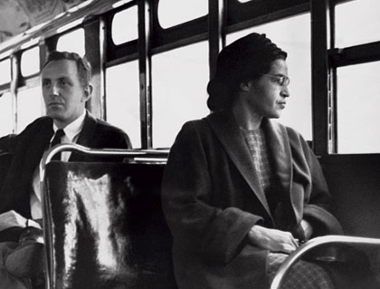

1. How did Rosa Parks feel when the bus driver told her to get up?

scared

excited

tired

shy

1. When people write about Rosa Parks, which word would **best** describe her?

kind

brave

a bully

hard working

1. African Americans said they would not ride on any buses. This was called a boycott. What is a boycott?

Only boys can ride the bus.

Only white men and boys can ride the bus.

When a group of people refuse to use something.

Boys are the only group that cannot ride the bus.

1. Who was the minister that encouraged African Americans not to ride the bus?

George Washington

Abraham Lincoln

Martin Luther King, Jr.

Harriet Tubman

Do you think Rosa Parks did the right thing when she refused to give up her seat on the bus? Write at least 3 reasons for your opinion.